1. Call to order at**: 2:01 pm** 
   1. Roll call

* VP of Inter-Club Council Joshua Chin
* ICC Secretary Vacant
* ICC Finance Director Alan Tran
* ICC Outreach Director Sanne Hoogenraad
* ICC Media Coordinator Austin Fujii
* ICC Marketing Director Sofi Goldwater
* ICC Events Coordinator Sami Parikh
* ASFC ICC Advisor Victoria Strelnikova
* Active Minds Of Foothill College
* Animal Welfare Club
* Anime Club
* Anthropology Club
* Asian American Association
* Astronomy Club
* Burmese Student Association
* Business and Entrepreneurship Club
* Career Development Association
* Chess Club
* Chinese Campus Fellowship (CCF)
* Christians on Campus
* Cognitive Science Club
* Computer Engineering Club
* Computer Science Club
* Conservation Club
* Current Events Club
* Cymatics Clubs
* Data Science & AI Club
* Dental Hygiene Club
* Desi Student Union
* Disability Awareness Club
* Economics Club
* Electrical Engineering Club
* Enactus Club
* Engineering Club
* EOPS Ambassadors
* FHDA NASA Connect Club
* Fiber Arts Club
* Foothill American Chemical Society
* Foothill Archery
* Foothill Beats
* Foothill Biology Club
* Foothill Book Club
* Foothill Consulting
* Foothill Deduction Club
* Foothill Fashion Club
* Foothill Film Club
* Foothill Fishing Club
* Foothill Physics Club
* Foothill Pre-Health Education Club
* Foothill Printmakers
* Foothill Table Tennis Club
* Foothill Taiwanese Student & Culture Association
* Foothill Ultimate Frisbee
* Fund the Future
* Games Club
* Gender and Sexualities Alliance (GSA)
* Global Medical/Dental Brigade
* Hip Hop Club
* Home and Middle College Alliance
* Hong Kong Student Union
* Honors Connection Club
* Inno Fintech Club
* International Kitchen Club
* International Students Connection Club
* InterVarsity Christian Fellowship
* Investment Club
* Jewish Student Union (JSU)
* Korean Club
* Los Jaguares
* Math Club
* Muslim Student Association
* National Society of Leadership and Success (NSLS) - Foothill Chapter
* NextGEN Innovators
* Owls for Palestine
* Photography Club
* Pickleball Club
* PreMed Pioneers Club
* Principia STEM Magazine
* Psychology Club
* Puente Club
* Quantum Technologies Student Club
* Rad Tech Club
* Research Club
* Respiratory Therapy Club
* Robotics Club
* Server Project Hub
* Skate Club
* Social Justice Club
* Speech and Debate
* Start Up Club
* Statistics Club
* Student Veterans of America
* The Script
* Traditional Chinese Calligraphy Club
* Virtual Reality Club
* Vocal Club
* Weightlifting Club
* Women in Business Club
* Women in Engineering
* Women In Stem
* Yoga and Meditation Club
  1. Approval of the Previous Minutes
     1. Previous minutes: <https://docs.google.com/document/d/12FKJELCkaKJPkpk3Biw5c-22GEiThZ3DwzSgHMMuk7U/edit?usp=sharing>
        1. **Minutes are approved by general consent.**

1. Public Comment
   1. Members of the public may make any announcements at this time. Announcements are limited to three minutes with no discussion.
      1. **Public comment received.**
2. Advisor Update
   1. The ASFC Advisor(s) will provide a weekly update on ASFC Business pertaining to the ASFC Inter-Club Council.
      1. **Advisor update received.**
3. Executive Update
   1. The ASFC Inter-Club Council Board will provide a weekly update on ASFC Business pertaining to the ASFC Inter-Club Council. The Inter-Club Council Board consists of the VP of Inter-Club Council, the ICC Secretary, the ICC Finance Director, the ICC Outreach Director, the ICC Marketing Director, the ICC Media Coordinator, and the ICC Events Coordinator.
      1. **Report received.**
      2. Wednesday, Nov 20th is from 1 to 2 pm is the advisor lunch and learn. Please let your advisors know to check their emails for the invitation. This is a chance for ICC to meet with them as well as go over what being an advisor is and (hopefully) get more faculty/staff involved as well.
         1. **Report received.**
      3. If you haven’t sent me your club info, scan this qr code
         1. **Report received.**

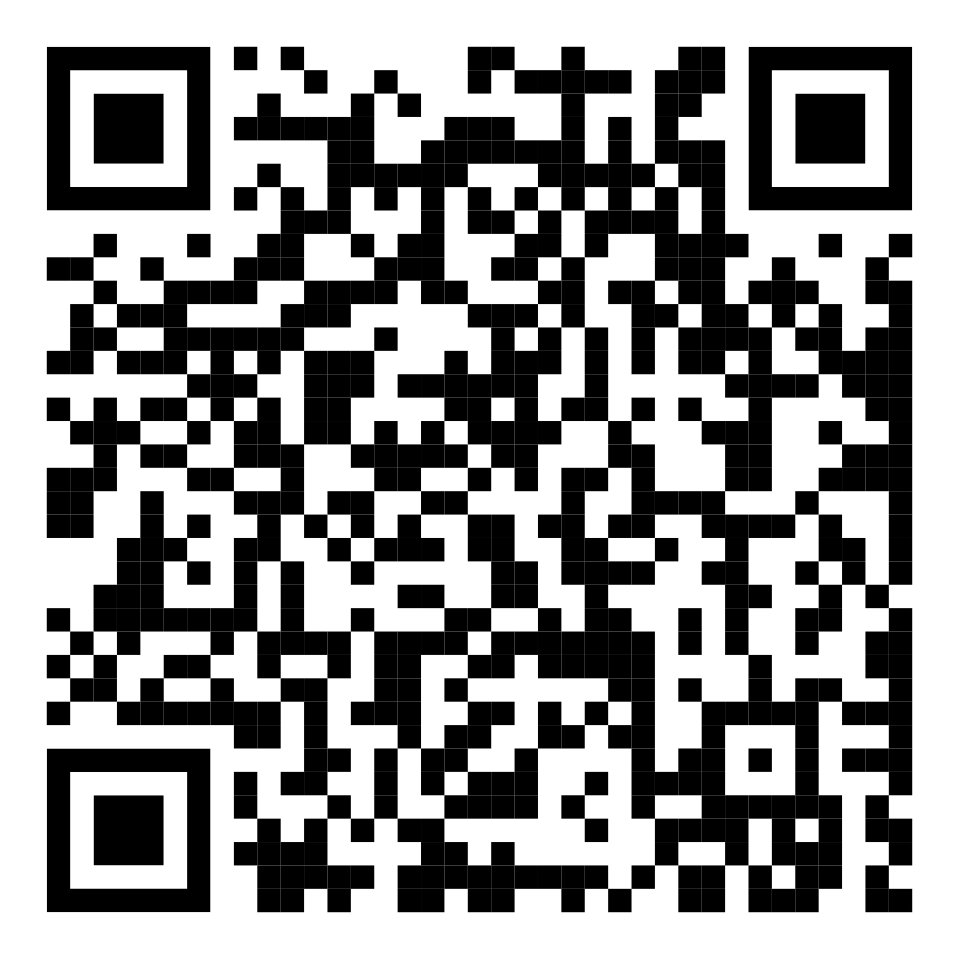

1. Activity Petitions <https://drive.google.com/drive/folders/1vUemtBaOKesMxWGTN4nKYRJg0zxlrYF2?usp=sharing>
   1. ASFC Inter-Club Council will discuss and possibly take action on approving Engineering Club’s CAD Workshop from 3 pm to 5 pm, January 10th.
      1. **I, Devansh Kanda, representing Engineering Club, move to approve Engineering Club’s CAD Workshop from 3 pm to 5 pm in room 4716 on January 10th.**
         1. **Seconded**
            1. **Motion is approved by general consent.**
   2. ASFC Inter-Club Council will discuss and possibly take action on approving International Student Connection Club’s Thanksgiving Gathering on November 22nd at Rengstorff Park from 1 to 4 pm.
      1. **I, Ocean Ko, representing International Student Connection Club, move to approve International Student Connection Club’s Thanksgiving Gathering on November 22nd at Rengstorff Park from 1 to 4 pm.**
         1. **Seconded**
            1. **Motion is approved by general consent.**
   3. ASFC Inter-Club Council will discuss and possibly take action on approving Women in Engineering Club’s Highlighting Women in Engineering Speaker Panel on November 22nd from 11 am to 12 pm in Room 4203.
      1. **I, Sarah Gibbs, representing Women in Engineering Club, move to approve Women in Engineering Club’s Highlighting Women in Engineering Speaker Panel on November 22nd from 11 am to 12 pm in Room 4203.**
         1. **Seconded**
            1. **Motion is approved by general consent.**
   4. ASFC Inter-Club Council will discuss and possibly take action on approving Social Justice Club’s Film Screening “Where Olive Trees Weep” in the Appreciation Hall on November 26th, from 12 pm to 2 pm.
      1. **I, Shams Alwan, representing Social Justice Club, move to approve Social Justice Club’s Film Screening “Where Olive Trees Weep” possibly in room 5015 on November 26th, from 12 pm to 2 pm.**
         1. **Seconded**
            1. **Motion is approved by general consent.**
   5. **ASFC Inter-Club Council will discuss and possibly take action Animal Welfare Club’s Making Toys for dogs and cats in the Learning Center, on December 3rd at 12pm to 4pm.**
      1. **I, Lingling Hu, representing Welfare Club, move to approve Welfare Club’s Making Toys for dogs and cats in the Learning Center, on December 3rd at 12pm to 4pm.**
         1. **Seconded**
            1. **Motion is approved by general consent.**
   6. **ASFC Inter-Club Council will discuss and possibly take action on approving Pre-Med Club’s Thanksgiving Event in room 4602 on November 23rd from 5pm to 7pm.**
      1. **I, Jean* Pierre Mououdj, representing Math Club, move to approve Pre-Med Club’s Thanksgiving Event in room 4602 on November 23rd from 5pm to 7pm.**
         1. **Seconded**
            1. **This motion is approved by general consent.**
2. Fund Requests Per<https://drive.google.com/drive/folders/1CY4At2Qs-Syiu3-lduOWtpvwkHImnx20?usp=drive_link>
   1. ASFC Inter-Club Council will discuss and possibly take action on approving the $200 Annual Grant for Math Club **and Korean Club** for the 24 to 25 academic year.
      1. **I, Jean* Pierre Mououdj, representing Math Club, move to approve the $200 Annual Grant for Math Club and Korean Club for the 24 to 25 academic year.**
         1. **Seconded**
            1. **Motion is approved by general consent.**
   2. ASFC Inter-Club Council will discuss and possibly take action on approving the $250 for the Annual Grant and New Seed Fund for Women In Engineering for the 24 to 25 academic year.
      1. **I, Sarah Gibbs, representing Women Engineering Club, move to approve the $250 for the Annual Grant and New Seed Fund for Women In Engineering for the 24 to 25 academic year.**
         1. **Seconded**
            1. **This motion is approved by general consent.**
   3. ASFC Inter-Club Council will discuss and possibly take action on approving the $500 Special Activities Fund fo**r Anime Club, Pre-Med Pioneer Club, Animal Welfare, International Students Connection and Engineering Club** for the 24 to 25 academic year.
      1. **I, Devansh Kanda, representing Engineering Club, move to approve the $500 Special Activities Fund for Anime Club, Pre-Med Pioneer Club, Animal Welfare, International Students Connection and Engineering Club for the 24 to 25 academic year.**
         1. **Seconded**
            1. **This motion is approved by general consent.**
3. Old Business
   1. No old business
      1. **No old business**
4. New Business
   1. No new business
      1. **No new business**
5. Announcements
   1. Announcements
      1. The members of the ASFC Inter Club Council will provide any announcements. The members of the Inter Club Council constitute the members of the ICC Board, ASFC Elected Members, ASFC Appointed Members, ASFC Agents, ASFC Lifetime Members and ASFC Inter-Club Council Representatives.
         1. **Report received.**
6. Open Forum
   1. During Open Forum any member of the Foothill Community or the Public may participate in conversation regarding any topic pertaining to ASFC Clubs.
      1. **Open Forum received**
7. Written Reports
   1. All reports made to the Inter-Club Council must be submitted to this form. <https://forms.gle/uUVwoFSMFwCimHx2A>
      1. **Report received.**
8. Adjournment
   * 1. The Chair adjourns the meeting at: **3:00 pm**