1. Call to order at**: 2:05 PM**
   * VP of Inter-Club Council Joshua Chin
   * ICC Secretary Amnah Khan
   * ICC Finance Director Alan Tran
   * ICC Outreach Director Sanne Hoogenraad
   * ICC Media Coordinator [Vacant]
   * ICC Marketing Director Sofi Goldwater
   * ICC Events Coordinator Sami Parikh
   * ASFC ICC Advisor Victoria Strelnikova

* ~~Afghan Student Association~~
* ~~American Chemical Society~~
* ~~Anthropology Club~~
* ~~Asian American Association~~
* ~~Badminton Club~~
* ~~Biology Club~~
* ~~Black Student Union~~
* ~~Book Club~~
* ~~Burmese Student Association~~
* ~~Business and Entrepreneurship Club~~
* ~~CHA Consulting~~
* ~~Chinese Campus Fellowship~~
* ~~Chinese Students Scholars Association~~
* ~~Christians on Campus~~
* ~~Climbing Club~~
* ~~Cognitive Science Club~~
* ~~Computer Science Club~~
* ~~Conservation and Ecology Club~~
* ~~Current Events Club~~
* ~~Data Science and AI Club~~
* Dental Hygiene Club
* ~~Disability Advocacy Club~~
* ~~Enactus~~
* Engineering Club
* ~~Fiber Arts Club~~
* ~~Foothill Beats~~
* ~~Foothill Printmakers~~
* ~~Fund the Future~~
* ~~Games Club~~
* ~~Genders and Sexualities Alliance~~
* ~~Global Medical/Dental Brigade Club~~
* ~~Hong Kong Student Union~~
* ~~Honors Connection Club~~
* ~~Horticulture Club~~
* ~~Intervarsity Club~~
* ~~Japanese Culture Club~~
* ~~Justice for Muwekma~~
* ~~Kasama Club~~
* ~~Korean Club~~
* ~~Los Jaguares~~
* Math Club
* ~~Muslim Student Association~~
* NEXTGEN innovators
* ~~Owls For Palestine~~
* ~~Photography Club~~
* ~~Pickleball Club~~
* Pre Health Education Club
* Principia STEM Magazine
* ~~Psychology Club~~
* ~~Rad Tech Club~~
* ~~Respiratory Therapy Club~~
* Robotics Club
* ~~Rocketry Club~~
* ~~Social Justice Club~~
* ~~Startup Club~~
* ~~Table Tennis Club~~
* ~~Taiwanese Student Association~~
* ~~The Script~~
* ~~Ultimate Frisbee Club~~
* ~~Women in Business~~
* ~~Women in Engineering~~

1. Approval of the Previous Minutes
   1. Previous minutes: <https://docs.google.com/document/d/1PFMVwJW9CU2NMIc2k_g-5hFueD-LXCymYyOO1ezhcy8/edit?tab=t.0>
      1. **Minutes approved by general consent.**
2. Public Comment
   1. Members of the public may make any announcements at this time. Announcements are limited to three minutes with no discussion.
      1. **No public comment.**
3. Advisor Update
   1. The ASFC Advisor(s) will provide a weekly update on ASFC Business pertaining to the ASFC Inter-Club Council.
      1. **Report received.**
4. Administration Board Presentation
   1. 
      1. Owl Card benefits survey
         1. **Report received.**
5. Executive Update
   1. The ASFC Inter-Club Council Board will provide a weekly update on ASFC Business pertaining to the ASFC Inter-Club Council. The Inter-Club Council Board consists of the VP of Inter-Club Council, the ICC Secretary, the ICC Finance Director, the ICC Outreach Director, the ICC Marketing Director, the ICC Media Coordinator, and the ICC Events Coordinator.
      1. Funding processes overview.
         1. **Report received.**
6. Activity Petitions <https://drive.google.com/drive/folders/1vUemtBaOKesMxWGTN4nKYRJg0zxlrYF2?usp=sharing>
   1. No activity petitions.
7. Fund Requests Per<https://drive.google.com/drive/folders/1CY4At2Qs-Syiu3-lduOWtpvwkHImnx20?usp=drive_link>
   1. ASFC Inter-Club Council will discuss and possibly take action on approving the $200 Annual Grant for Kasama Club for the 24 to 25 academic year.
      1. **Tabled for next week.**
   2. ASFC Inter-Club Council will discuss and possibly take action on approving the $250 Annual Grant and New Seed Fund for Horticulture Club for the 24 to 25 academic year.
      1. **I, Linda, representing Horticulture Club, move to approve the $250 Annual Grant and New Seed Fund for Horticulture Club for the 24 to 25 academic year.**
         1. **Seconded.**
            1. **Motion approved by general consent.**
8. Old Business
   1. Funding processes overview.
      1. **Report received.**
9. New Business
   1. No new business.
      1. **No new business.**
10. Announcements
    1. Announcements
       1. The members of the ASFC Inter Club Council will provide any announcements. The members of the Inter Club Council constitute the members of the ICC Board, ASFC Elected Members, ASFC Appointed Members, ASFC Agents, ASFC Lifetime Members and ASFC Inter-Club Council Representatives.
          1. Winter Ball - 70s theme! February 27th 6-9 PM in the Dining Hall
             1. **Report received.**
          2. 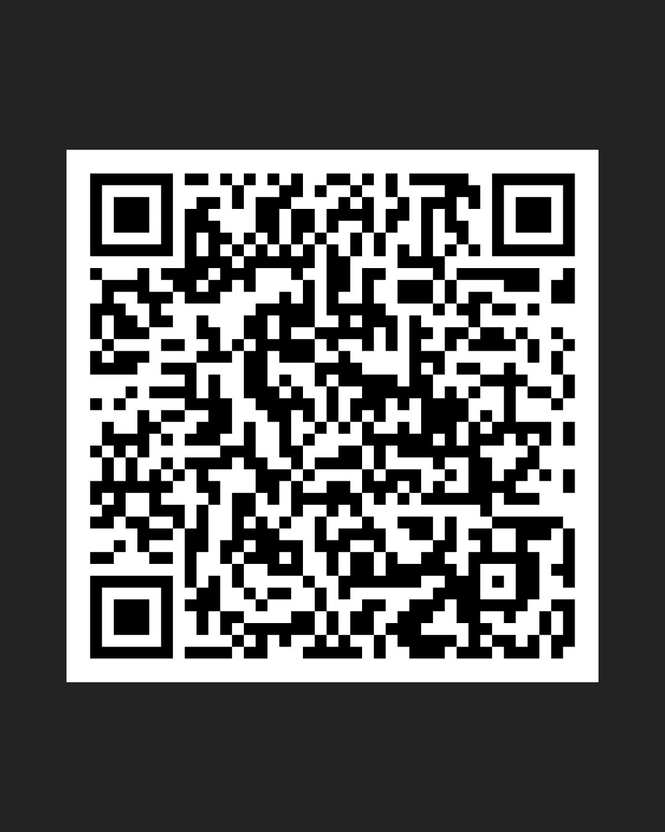ASFC student survey
             1. **Report received.**
11. Open Forum
    1. During Open Forum any member of the Foothill Community or the Public may participate in conversation regarding any topic pertaining to ASFC Clubs.
       1. **Open forum received.**
12. Action Items and Important Links
    1. All reports made to the Inter-Club Council must be submitted to this form. <https://forms.gle/uUVwoFSMFwCimHx2A>
    2. Fill out [club information form](https://docs.google.com/forms/d/e/1FAIpQLSe7oHJrDPX0aBdYCjrJ5PxfUDaYmbT7Swpsd86jEYf9nKI-gA/viewform?usp=sharing)
    3. Send in your club constitutions!
    4. [Feedback](https://docs.google.com/forms/d/e/1FAIpQLSefc_c4CGP4InNXL9NIP52k6wt53y0_suMR3mB0HbwqA_Kjeg/viewform)
    5. [Event Checklist](https://docs.google.com/document/d/1_iz-IzOKeSrscjLJxrmb-jK5_UuYfzDzg8QUSy-ZsIk/edit?tab=t.0)
    6. [Event Support Questionnaire](https://docs.google.com/forms/d/1J6E6jDC1UXG3hcU3lB7ihCRZYagKsEtIx460QicYYrA/edit)
13. Adjournment
    * 1. The Chair adjourns the meeting at: **2:49 PM**