PROGRAM REVIEW INSTRUCTIONAL DISCIPLINE TEMPLATE

PROGRAM MISSION STATEMENT
Missions Statement:

PROGRAM LEVEL STUDENT LEARNING OUTCOMES
Please list the program level student learning outcomes:

ENROLLMENT TRENDS
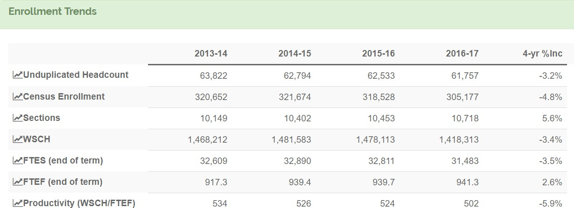

FTES – ENROLLMENT TRENDS
  - In the data table above, what does the FTES data trend indicate?
    - the data trend shows an increase in FTES
    - the data trend shows a decrease in FTES
    - the data trend shows no change

Discuss the factors that would help the college understand these trends and whether there are tangible reasons for the increase or decrease. (100 words or less)

  - Looking at the data trend, has the faculty/staff discussed proposed actions to stabilize/increase FTES?
    - yes ☐ no
If yes, describe the proposed actions for stabilizing/increasing the FTES. (100 words or less)

SECTIONS – ENROLLMENT TRENDS

  - In the data table above, what does the data trend indicate about the number of sections offered?
    - the data trend shows an increase in sections
    - the data trend shows a decrease in sections
    - the data trend shows no change

If the data trend shows an increase or decrease in sections, explain why the number of sections increased or decreased. (100 words or less)

If the data indicates an increase in sections with a decrease in FTES, explain why the number of sections increased while FTES decreased. (100 words or less)

PRODUCTIVITY – ENROLLMENT TRENDS

[WILL INCLUDE MAXIMUM PRODUCTIVITY CHART]

  - In the data table above, what does the data trend indicate about the productivity trend?
    - the data trend shows the productivity number increased
    - the data trend shows the productivity number decreased
    - the data trend shows no change in the productivity number

If the data trend shows an increase or decrease in productivity, explain why the productivity increased or decreased. (100 words or less)

  - Does the data trend suggest changes are necessary to improve productivity? ☐ yes ☐ no

If yes, describe the proposed actions for stabilizing/increasing the productivity number. (100 words or less)

ENROLLMENT BY STUDENT DEMOGRAPHICS

ENROLLMENT BY GENDER
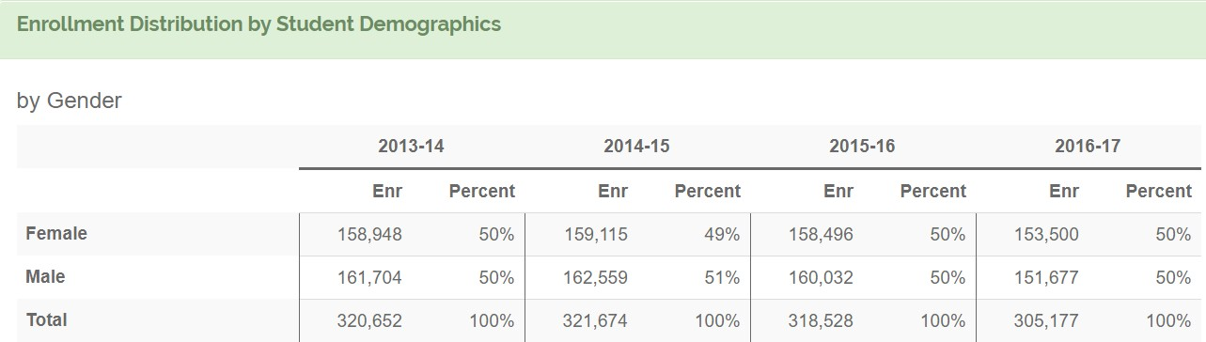

  - In the data table above, what does the data trend indicate about program enrollment by gender?

FEMALES
    - the data trend shows an increase in the female enrollment rates
    - the data trend shows a decrease in the female enrollment rates
    - the data trend shows no change for female students

MALES
    - the data trend shows an increase in the male enrollment rates
    - the data trend shows a decrease in the male enrollment rates
    - the data trend shows no change for male students

If the data trend shows a change in male or female enrollment, explain why there was a change. (100 words or less)
  - Does your program differ in the percentage of males to females compared to the College average?
    - yes ☐ no
If the data indicates a lack of gender parity in your program as compared to the college percentages, what is the source of that disparity and what is the program doing/planning to address this? (100 words or less)

 | Enrollment (Headcount) Distribution by Declared Majors in the Program
 | 2013-2014 |  | 2014-2015 |  | 2015-2016 |  | 2016-2017
 | Enr | Percent | Enr | Percent | Enr | Percent | Enr | Percent
Female
Male

  - In the data table above, what does the data trend indicate about enrollment (headcount) by gender of declared majors in the program?

FEMALES
    - the data trend shows an increase in the female enrollment of the declared major
    - the data trend shows a decrease in the female enrollment of the declared major
    - the data trend shows no change for female students

MALES
    - the data trend shows an increase in the male enrollment of the declared major
    - the data trend shows a decrease in the male enrollment of the declared major
    - the data trend shows no change for male students
Is there a gender disparity compared to the college for the programs’ declared majors? (100 words or less)

  - Do the data suggest changes are necessary to improve female or male enrollment rates?
    - yes ☐ no

If yes, describe the proposed actions for stabilizing/improving female or male enrollment rates. (Limit your answer to a bullet point for each course)

