PROGRAM REVIEW INSTRUCTIONAL DISCIPLINE TEMPLATE

PROGRAM MISSION STATEMENT
Missions Statement:

PROGRAM LEVEL STUDENT LEARNING OUTCOMES
Please list the program level student learning outcomes:

ENROLLMENT TRENDS
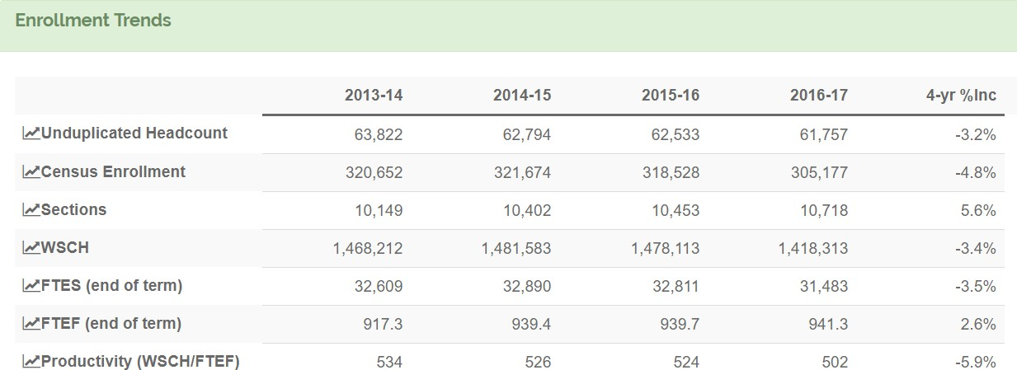

FTES – ENROLLMENT TRENDS
  - In the data table above, what does the FTES data trend indicate?
    - the data trend shows an increase in FTES
    - the data trend shows a decrease in FTES
    - the data trend shows no change

Discuss the factors that would help the college understand these trends and whether there are tangible reasons for the increase or decrease. (100 words or less)

  - Looking at the data trend, has the faculty/staff discussed proposed actions to stabilize/increase FTES?
    - yes ☐ no
If yes, describe the proposed actions for stabilizing/increasing the FTES. (100 words or less)

SECTIONS – ENROLLMENT TRENDS

  - In the data table above, what does the data trend indicate about the number of sections offered?
    - the data trend shows an increase in sections
    - the data trend shows a decrease in sections
    - the data trend shows no change

If the data trend shows an increase or decrease in sections, explain why the number of sections increased or decreased. (100 words or less)

If the data indicates an increase in sections with a decrease in FTES, explain why the number of sections increased while FTES decreased. (100 words or less)

