PROGRAM REVIEW
INSTRUCTIONAL DISCIPLINE TEMPLATE

PROGRAM MISSION STATEMENT

Missions Statement:

PROGRAM LEVEL STUDENT LEARNING OUTCOMES

Please list the program level student learning outcomes:

ENROLLMENT TRENDS

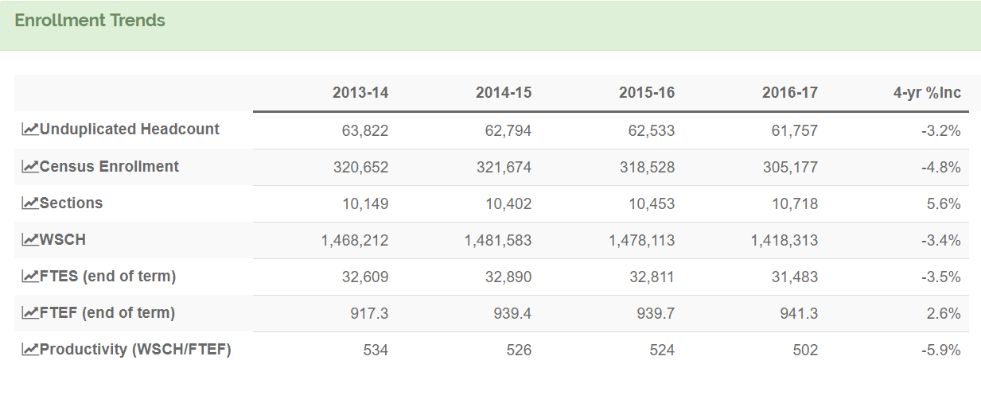

- FTES – ENROLLMENT TRENDS

- What does the data table above indicate about the FTES enrollment trends in the program?
☐ the data trend shows an increase in FTES
☐ the data trend shows a decrease in FTES
☐ the data trend shows no change

Discuss the factors that would help the college understand these trends and whether there are tangible reasons for the increase or decrease. (100 words or less)

- Looking at the data trends, has the faculty/staff discussed proposed actions to stabilize/increase FTES?
☐ yes ☐ no
If yes, describe the proposed actions for stabilizing/increasing the FTES. (100 words or less)

- SECTIONS – ENROLLMENT TRENDS

- In the data table above what does, the data indicate about the number of sections offered?
☐ the data trend shows an increase in sections
☐ the data trend shows a decrease in sections
☐ the data trend shows no change

If the data trend shows an increase or decrease in sections, explain why the number of sections increased or decreased. (100 words or less)

If the data indicates an increase in sections with a decrease in FTES, explain why the number of sections increased while FTES decreased. (100 words or less)

- PRODUCTIVITY – ENROLLMENT TRENDS

- In the data table above, what does the data indicate about the productivity number overtime?
☐ the data trend shows an increase in the productivity number
☐ the data trend shows a decrease in the productivity number
☐ the data trend shows no change
If the data trend shows an increase or decrease in productivity, explain why the productivity increased or decreased. (100 words or less)

- Does the data suggest that changes are necessary to improve productivity? ☐ yes ☐ no
If yes, describe the proposed actions for stabilizing/increasing the productivity. (100 words or less)

- 3-YEAR AVERAGE COURSE FILL RATE – ENROLLMENT TRENDS

Dental Hygiene
Division | Department | Course | 3-Year Average Fill Rate
1BH | D H | F050 | 94%
1BH | D H | F052A | 100%
1BH | D H | F052B | 92%
1BH | D H | F053. | 100%
1BH | D H | F054. | 100%
1BH | D H | F055A | 92%
1BH | D H | F055B | 90%
1BH | D H | F056. | 55%
1BH | D H | F057A | 92%
1BH | D H | F057B | 90%
1BH | D H | F057C | 90%
1BH | D H | F058A | 92%
1BH | D H | F058B | 92%
1BH | D H | F058C | 92%
1BH | D H | F059. | 100%
1BH | D H | F060A | 100%
1BH | D H | F060B | 92%
1BH | D H | F060C | 90%
1BH | D H | F060D | 90%
1BH | D H | F060E | 90%
1BH | D H | F061A | 92%
1BH | D H | F061B | 92%
1BH | D H | F062A | 90%
1BH | D H | F062B | 90%
1BH | D H | F062C | 90%
1BH | D H | F062D | 90%
1BH | D H | F063C | 90%
1BH | D H | F063D | 90%
1BH | D H | F064. | 90%
1BH | D H | F065. | 90%
1BH | D H | F066. | 96%
1BH | D H | F067. | 90%
1BH | D H | F068A | 92%
1BH | D H | F070R | 196%
1BH | D H | F071. | 92%
1BH | D H | F071R | n/a
1BH | D H | F072. | 92%
1BH | D H | F073. | 92%
1BH | D H | F075A | 90%
1BH | D H | F075B | 90%
1BH | D H | F075C | 90%
1BH | D H | F200L | 61%
1BH | D H | F300A | 100%
1BH | D H | F300B | 96%
1BH | D H | F302. | 100%
1BH | D H | F304. | 100%
1BH | D H | F305A | 100%
1BH | D H | F305B | 96%
1BH | D H | F305C | 96%
1BH | D H | F308. | 96%
1BH | D H | F310. | 96%
1BH | D H | F312. | 96%
1BH | D H | F314. | 96%
1BH | D H | F316A | 96%
1BH | D H | F318. | 96%

- In the data table above, what does the data indicate about the fill-rate for individual courses?
☐ the data shows there are course(s) with a lower than 80% fill-rate
☐ the data shows that all courses have a fill-rate of 80% or more
If the data shows courses with a fill-rate lower than 80%, for each course, explain why the fill-rate is lower than 80%. (limit your answer to a bullet point for each course)

- Does the data suggest changes are necessary to improve course fill-rates? ☐ yes ☐ no

If yes, describe the proposed actions for stabilizing/improving the course fill-rate. (Limit your answer to a bullet point for each course)

- ENROLLMENT BY STUDENT DEMOGRAPHICS

  - ENROLLMENT BY GENDER

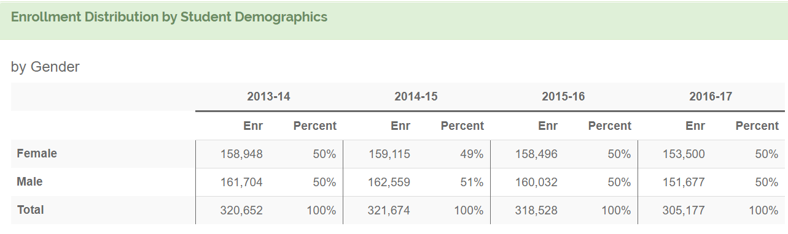

- In the data table above, what does the data indicate about program enrollment by gender?

FEMALES
☐ the data trend shows an increase in the female enrollment rates
☐ the data trend shows a decrease in the female enrollment rates
☐ the data trend shows no change for female students

MALES
☐ the data trend shows an increase in the male enrollment rates
☐ the data trend shows a decrease in the male enrollment rates
☐ the data trend shows no change for male students

If the data trend shows a change in male or female enrollment, explain why there was a change. (100 words or less)

- Does your program differ in the ratio of males to females compared to the College?
☐ yes ☐ no

If the data indicates a lack of gender parity in your program, what is the source of that disparity and what are you doing to address this? (100 words or less)

- Does the data suggest that changes are necessary to improve female or male enrollment rates?
☐ yes ☐ no

If yes, please describe the proposed actions for improvement. (100 words or less)

  - ENROLLMENT BY ENTHNICITY

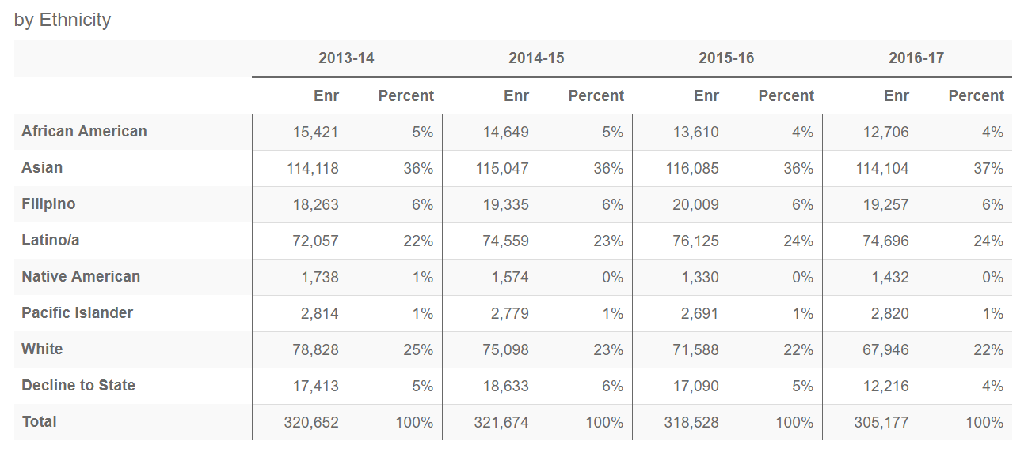

- In the data table above, what does the data indicate about program enrollment by ethnicity?

AFRICAN AMERICANS
☐ the data trend shows an increase in the African Americans enrollment rates
☐ the data trend shows a decrease in the African Americans enrollment rates
☐ the data trend shows no change for African Americans students

ASIAN
☐ the data trend shows an increase in the Asian enrollment rates
☐ the data trend shows a decrease in the Asian enrollment rates
☐ the data trend shows no change for Asian students

FILIPINO
☐ the data trend shows an increase in the Filipino enrollment rates
☐ the data trend shows a decrease in the Filipino enrollment rates
☐ the data trend shows no change for Filipino students

LATINO/A
☐ the data trend shows an increase in the Latino/a enrollment rates
☐ the data trend shows a decrease in the Latino/a course success rates
☐ the data trend shows no change for Latino/a students

NATIVE AMERICAN
☐ the data trend shows an increase in the Filipino enrollment rates
☐ the data trend shows a decrease in the Filipino course success rates
☐ the data trend shows no change for Filipino students

PACIFIC ISLANDER
☐ the data trend shows an increase in the Pacific Islander enrollment rates
☐ the data trend shows a decrease in the Pacific Islander enrollment rates
☐ the data trend shows no change for Pacific Islander students

WHITE
☐ the data trend shows an increase in the White enrollment rates
☐ the data trend shows a decrease in the White enrollment rates
☐ the data trend shows no change for White students

DECLINE TO STATE
☐ the data trend shows an increase in the decline to state enrollment rates
☐ the data trend shows a decrease in the decline to state enrollment rates
☐ the data trend shows no change for decline to state students
Looking at the categories above, explain changes identified in each category (use a separate bullet point for each category). (100 words or less)

- Does your program differ in enrollment distribution among ethnic groups compared to the College?

☐ yes ☐ no
Looking at the data, describe the reasons for the differences (100 words or less).

- Does the data suggest that programmatic actions are necessary to address ethnic disparities, including under enrollment by a particular group?

☐ yes ☐ no

If yes, describe the proposed actions for addressing ethnic disparities in your program. (100 words or less)

- STUDENT COURSE SUCCESS

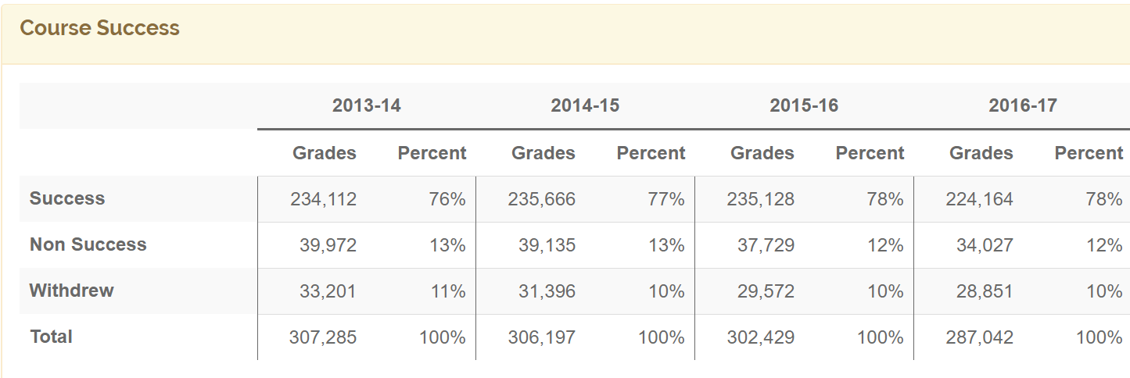

- In the data table above, what does the data indicate about overall course success?
☐ the data trend shows an increase in the students’ course success percentage
☐ the data trend shows a decrease in the students’ course success percentage
☐ the data trend shows no change

Looking at the data, explain what programmatic factors led to such a trend (increase, decrease, no change). (100 words or less)

What concrete actions are program faculty and staff engaged in to stabilize/increase the course success percentages. (100 words or less)

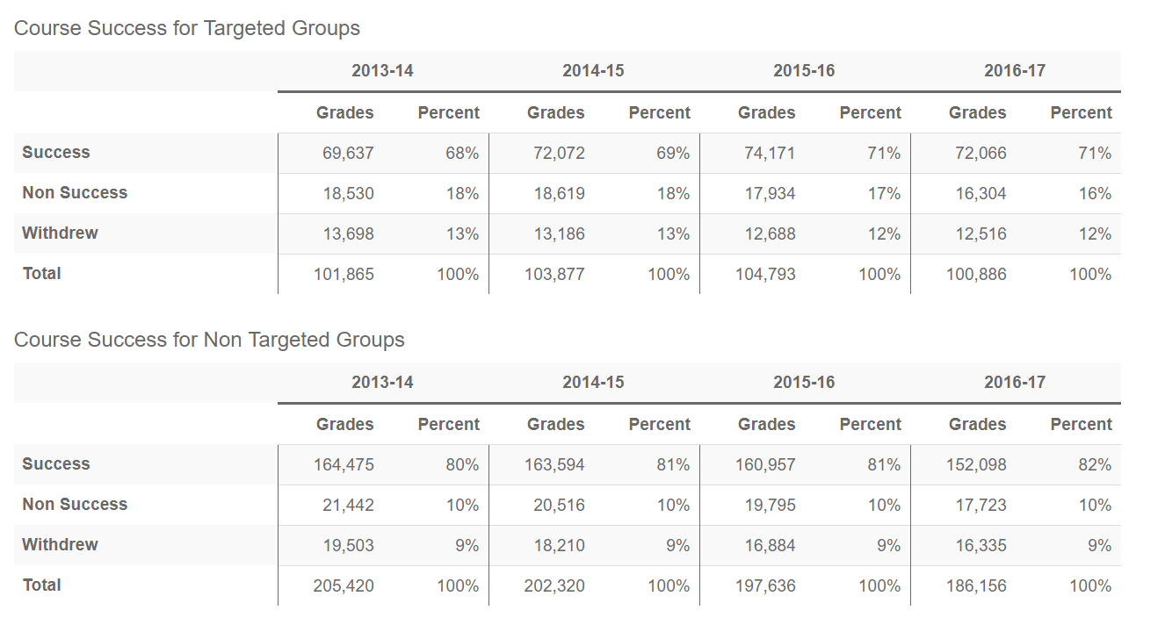

- In the data table above for student course success for TARGETED GROUPS what is the observed trend?
☐ the data trend shows an increase in the students’ course success percentage
☐ the data trend shows a decrease in the students’ course success percentage
☐ the data trend shows no change

- In the data table above for student course success for NON-TARGETED GROUPS what is the observed trend?
☐ the data trend shows an increase in the students’ course success percentage
☐ the data trend shows a decrease in the students’ course success percentage
☐ the data trend shows no change
Explain what programmatic factors led to such a trend (use a separate bullet point for TARGETED and NON-TARGETED). (100 words or less)

