Faculty Out-of-Cycle Hiring Prioritization Request Form

December 8, 2015
Background
Requests for new faculty hires are normally made during the annual Program Review cycle. However, unexpected vacancies occasionally arise (e.g. due to retirement, resignation, death or long-term disability), and consequently, new hire requests fall outside the Program Review cycle. This would be an exception to the standard process where vacant positions go into a pool to be re-prioritized by the college as part of the normal hiring cycle.

Steps for out-of-cycle requests to fill vacant faculty positions:

- The department must make a specific request for an out-of-cycle hire to the Dean.

Statement of need – department should attach the most recent PR Data Sheet and written justification for the department retaining the position outside the normal process.

- Review the Out of Cycle Hiring Prioritizations Criteria Guidance at the end of this document for more information.
- Refer to the data sheets and the Instructional PR Data Summary spreadsheet when completing the statement of need that addresses these elements, where appropriate:
- Sole Full-Time Faculty Member
- Enrollment Trends
- Student Impact and Effect on Ability to Graduate (equity data required…)
- Programmatic Considerations (for AD-Ts, etc.)
- Reflection on Institutional Priorities (FTES, Online, Equity, EMP)

- A) Division Support strong support moderate support low support

B) Dean Support strong support moderate support low support
Dean’s Comments:
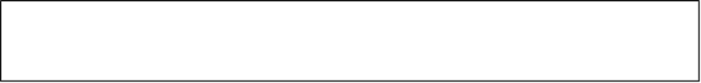

- Vice President recommendation to PaRC.
Support _______ Do Not Support _____________

Vice President’s Comments

- Department faculty members (the requestors) are invited to attend and advocate for their request at PaRC.

- PaRC recommendations to the College President.
Support _______ Do Not Support _____________

- College President
Accept ___________ Reject _____________recommendation

President’s Rationale
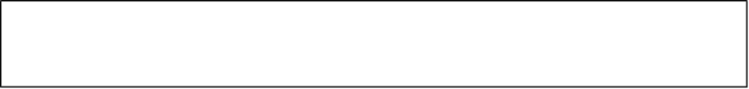

Foothill College

Out of Cycle Hiring Prioritizations Criteria Guidance

December 8, 2015
- Sole Full Time Faculty Member
  - Is there at least one full time faculty in the department who can be responsible for essential functions such as curriculum development and maintenance, program review, and student learning outcome assessment and reflection?
  - Guiding principle: Both students and faculty are best served when there is at least one full time faculty member who can guide these initiatives

- Enrollment Trends
  - Is enrollment going up, down, or staying approximately consistent?
  - Guiding principle: The request for the full time faculty hire is strengthened if enrollment has been going up or staying constant

- Student Impact and Effect on Ability to Graduate
  - Do students need courses in this department to be able to progress on a pathway to graduate (for example, basic skills math, English, ESL)?
  - Guiding principle: The request for the full time faculty hire is strengthened if the department courses serve as pathway courses for degree completion, especially for under-served populations.

- Programmatic Considerations (for ADTs, etc.)
  - Are program completion numbers on the rise or staying consistent? Are courses in department needed for program-specific requirements, and/or courses that meet general education requirements for many different programs? If no full time faculty, will it prevent ability to offer courses needed for program completion?
  - Guiding principles: The hiring request is strengthened if
    - program completion numbers are increasing, and/or
    - the department offers courses that are core courses for a degree or certificate
- Relationship to Institutional Priorities (FTES goals, Equity Goals, Ed Master Plan Goals, etc.)
  - FTES
    - Is the department maintaining or increasing in FTES while maintaining a productivity level near the college target?
    - Guiding principle: The request for the full time faculty hire is strengthened if FTES has been going up or staying constant and productivity is at or above the college target.
  - Equity
    - Does this department serve a high percentage of disproportionately impacted groups? Does the department’s data suggest there are student groups being disproportionately impacted (particularly student groups that are traditionally underserved)? Absolute? Relative to the college’s trends?
    - Guiding principle: Having a greater proportion of full time faculty is positively correlated with student success,. Thus, to increase student success the legislature has set a goal that each college have 75% full time faculty. The further away the requesting department is from the goal of 75%, the more this substantiates the need for the hire.
  - Ed Master Plan Goals
    - How does the department contribute to achieving the goals identified in the Ed Master Plan?
    - Guiding principle: Departments that have identified strong ties to the Ed Master Plan goals have a stronger hiring request
  - Institution Set Standards
    - The college has identified a standard for a minimum acceptable institutional course success rate.
    - Guiding principles: Departments close to, or below, this minimum standard course success rate will have a stronger full time faculty hiring request.

http://www.asccc.org/sites/default/files/Rostrum_Sep08.pdf
http://www.asccc.org/content/7525-faculty-obligation-number-or-why-are-we-not-all-there-yet

