Student’s Guide to Accommodations Testing
The Testing Accommodations Process provides a way to coordinate testing for students who need accommodations. The success of the Testing Accommodation Process depends upon all of us doing our part: faculty, students, and staff.
Between one week before and two weeks after the start of each quarter
- Register with the Disability Resource Center to become eligible for testing accommodations.
- Once eligible, you may for accommodations each quarter, students should go to www.foothill.edu/al and click on “Accommodations Request” on the left. Students are advised to go to all their classes first and review their class syllabi before requesting accommodations.
- The Disability Resource Center will send an Accommodations Notification with details about your accommodation needs via email to your instructors and you.
Within ten business days of receiving the Accommodations Notification
- Meet with your instructor to discuss accommodations and coordinate testing dates and times.
After ten business days of receiving the Accommodations Notification
- If you and your instructor decide to use the Testing Center, schedule exam dates/times at least one week in advance of exam date.
EXAMPLE
Sunday | Monday | Tuesday | Wednesday | Thursday | Friday | Saturday
6 | 7 | 8 | 9 | 10 | 11 | 12
 | Register  with DRC |  |  |  | Receive Accommodations Notification
13 | 14 | 15 | 16 | 17 | 18 | 19
 |  |  | Meet with instructor
20 | 21 | 22 | 23 | 24 | 25 | 26
 |  |  |  | Schedule Exam at Testing Center
27 | 28 | 29 | 30 | 31 | 1 | 2
 |  |  |  | First Exam

How to Schedule Accommodations Testing at the Testing Center
Go to the Testing Center webpage at http://www.registerblast.com/foothill/Home/Tab/253 | 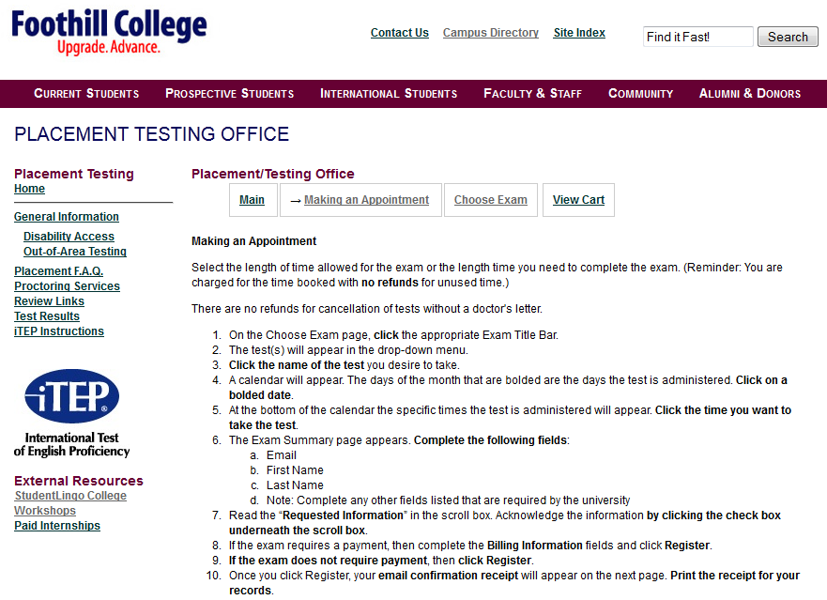
Step 1: Click on Choose Exam | 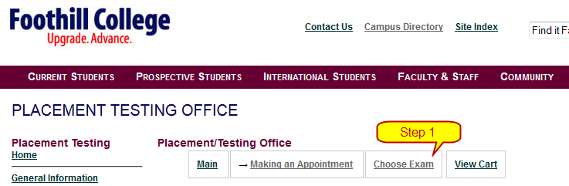
Step 2: Click on Accommodation Testing | 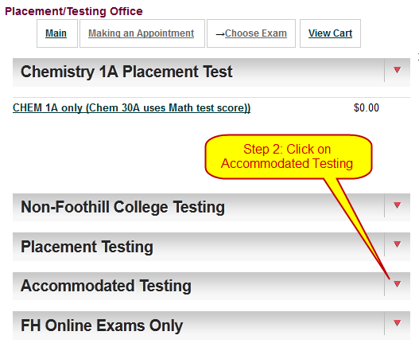
Step 3: Click on the number of minutes you need  for your exam. | 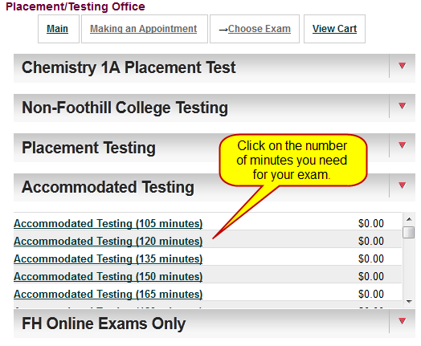
Step 4: Click on the date that you need to take the exam. | 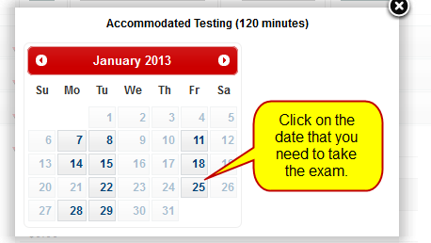
Step 5: Select the time that you need to take the exam. | 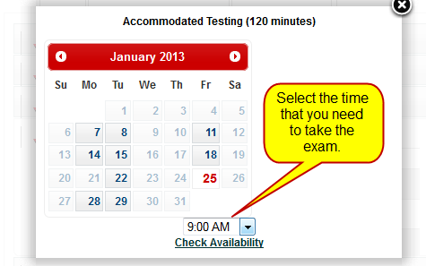
Step 6: Click on Check Availability. | 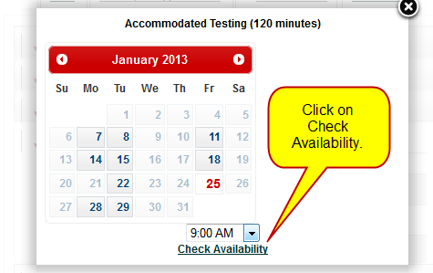
Step 7: Double check the date and time to be sure  that it is correct. If incorrect, click on Return to Cart. | 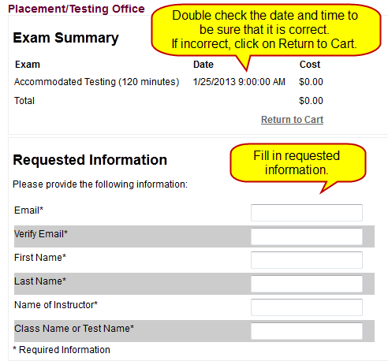
Step 8: Fill in the requested information.

Step 9: Check the acknowledgement box and click on Register button. | 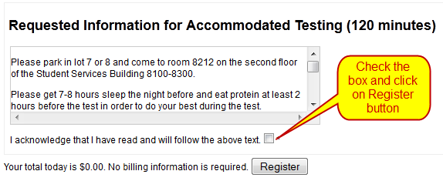
Step 10: Your email receipt will appear on the next webpage. Print this receipt for your records.

