Memo re: History and Current Status of SLOs

Questions before us now:
- Learning outcomes in context of meeting accreditation requirements:
  - Standards are clear: we must regularly assess SLOS, analyze and use the results in program review, and that they be tied to resource allocation and evaluation of institutional effectiveness
  - Timing of assessment/analysis is local decision
    - Per Kimberlee Messina: FH defined the cycle through shared governance as an annual one in order to best meet the rest of the standards regarding planning, program review and resource allocation.
    - Although “annual” is expected, each divisions has different “rules” in place about how many SLOs – every SLO every year? One SLO per course per year? One SLO per course per quarter? Etc.
      - Desire to standardize?
      - Clear communication needed, regardless whether/not all divisions are using the same timing
  - The needs to assess General Ed, Institution level LOs – are not being met by SLOAC co-coordinators structure – solution?
  - SLOs must now appear on Course Outlines of Record
    - how to meet this requirement?
    - Instructors should be able to change SLOs as needed – how to allow this without triggering the entire COR to move through C3MS again?
- Learning outcomes in context of being a valid tool for use by professional educators to reflect on their practice
  - What structure will best support faculty and staff going forward? Continue with SLO co-coordinators?
  - How can we foster ongoing campus dialog/engagement about student learning outcomes for programs, pathways, general ed, institution-level outcomes?
  - What mechanism/venue to facilitate collaborative reflection about outcomes across instruction and student services programs?
  - How can we better include part-time instructors? They teach half our classes.

Brief history of SLOs/coordination at Foothill College:

2008-10(?) Rosemary Arca – focus predominantly on course-level SLOs
10-11, 11-12 Gillian Schultz and Carolyn Holcroft were campus co-coordinators – focus was on course-level and program level LOs
12-14: “SLOAC Co-Coordinators”
- Receive stipend of $1000 per quarter
- Six instructional division positions and one service area coordinator position.
  - Roseann Berg (BHS); Katherine Schaefers (BSS); Fatima Jinnah (CNSL);
- Responsible for:
  - Developing and presenting training and support for faculty and staff in your division in relation to TracDat software, Resource Allocation, assessment design and analysis and Program Review.
  - Attending division meetings, and/or division curriculum meetings to provide training and updates regarding SLOs.
  - Meeting quarterly with other SLOAC Coordinators to plan and report out on progress and projects.
  - Ongoing review of procedures and processes for Learning Outcomes (CL-SLOs, PL-SLOs, SA-SLOs, AU-SLOs) and Continuous Quality Improvement.
  - Regular communication with the Academic Senate and the Office of Instruction regarding SLO assessment and dialogue in your division.
  - Other duties appropriate to the SLOAC process, including attending appropriate conferences as needed.

Relevant Accreditation Standards:

From Standard I:
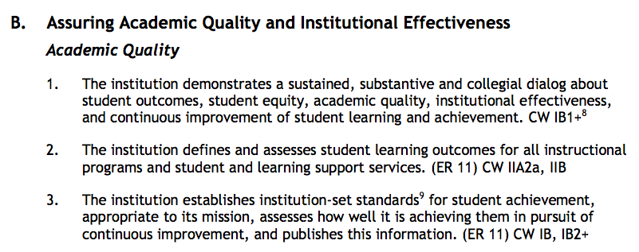
From Standard II:
