Memo re: SLOs and actions needed from Academic Senate
Issue | Current Status | Action Needed from Senate
Course-level SLOs required for accreditation: timing of SLOAC is a local decision | Currently at least one SLO per course per year. SLOAC documentation required for resource allocation, program review. | Formal support of this policy, or propose alternative policy and bring to shared governance bodies.
Part time faculty teach many classes/sections without receiving compensation for participating in SLOAC | Participation is voluntary. Lack of participation from all instructors teaching course defeats the intent of using SLOAC to foster dialog and learning from colleagues, to ultimate purpose of increasing student learning. | Collaborate with administration to procure ongoing funding for part-time faculty participation in SLOAC
Accreditation requires SLOAC for general education SLOs | Gen Ed SLOs (GE-SLOs) adopted by CCC in Spring 2010. Discussion at state level CCC about adopting LEAP essential learning outcomes, preliminary discussion of adopting LEAP for Foothill in Spring 2012 but no follow up to date. | Review/update of GE-SLOs needed (collaboration with CCC?)
 | GE-SLOs assessment/reflection currently sporadic. | Develop policy to ensure consistent SLOAC for our GE-SLOs
Accreditation requires SLOAC for institution-level SLOs | IL-SLOs SLOs initially developed as FRAMES 4-Cs (beginning 2005). | Review/update of IL-SLOs needed (collaboration with CCC?)
 | IL-SLOs assessment/reflection currently sporadic. | Develop policy to ensure consistent SLOAC for our IL-SLOs
Accreditation now requires that SLOs appear on the Course Outline of Record | SLOs are currently housed in TracDat, are not on our CORs in C3MS | Develop policy to meet accreditation mandate without harming flow of curriculum through 3CMS (collaborate with CCC)
Faculty need ongoing support with opportunities for collaborative reflection, professional development re: SLOs. | Current division SLO-coordinator structure not meeting needs in some divisions. Currently no venue for campus-wide discussion of SLOs (no space to for Instruction and Student Services to reflect on SLOs together) | Either formal support of current structure and commitment to ensure positions filled, or propose alternative structure
 | Senate passed three resolutions related to SLOs on 10/25/2010. | Review resolutions. Craft additional resolutions if needed.

Appendix A: SLO Resolutions passed by Foothill academic senate on October 25, 2010:
RESOLUTION 1: Support for Faculty Primacy in the Use of SLOs to Improve Student Learning

Whereas, the members of the Foothill College community are dedicated to the achievement of learning and to the success of our students;

Whereas, the cycle of SLO assessment empowers faculty to try new pedagogical approaches to explore both what works and what does not work, and encourages meaningful collegial dialogue about improvement of student learning;

Whereas, SLOs are intended to target deep learning beyond content alone and as such have the potential to stimulate both faculty and students to consider beneficial lifelong skills, values and behaviors that may be gained from a college education; and,

Whereas, The 2002 ACCJC accreditation standards require that colleges incorporate measurable student learning outcomes at the course, program and institutional level;

Resolved, the Foothill College Academic Senate supports the development and utilization of processes that honor faculty primacy in the identification and assessment of SLOs and that seek to utilize SLOs to their greatest potential in fostering student success.

RESOLUTION 2: SLOs on Course Syllabi
Whereas, when placed on the course syllabus, SLOs are made transparent to students and can prompt students to consider their own learning; and

Whereas, course-level SLOs are aligned with program and institutional-level learning outcomes and as such articulate a clear vision for student learning to the students;

Whereas, many students experience an increased motivation to learn when they have a clear understanding of how a course is going to benefit them in the long term;

Whereas, the 2002 ACCJC accreditation standards require that “in every class section students receive a course syllabus that specifies learning outcomes consistent with those in the institution’s officially approved course outline,”

Resolved, the Foothill College Academic Senate strongly encourages faculty to place SLOs on their course syllabus.

RESOLUTION 3: Opposition to Using SLOs in Faculty Evaluation
Whereas, Campus visiting teams for the Accrediting Commission for Community and Junior Colleges (ACCJC) have offered conflicting interpretations of Accreditation Standard III.A.1.c, leading to some team recommendations that the attainment of student learning outcomes should be included in individual faculty evaluations;

Whereas, The Academic Senate for California Community Colleges, in its 2004 paper, The 2002 Accreditation Standards: Implementation, has stated its opposition to the use of SLOs as a basis for faculty evaluation, noting the potentially negative impact on evaluation as a collegial peer process, on academic freedom, and on local bargaining authority;

Whereas, The Academic Senate for California Community Colleges noted in the same paper that “in the event that SLOs data is collected and aggregated, it must be without reference to specific classes, students and its instructors”; and

Whereas, The differing interpretations of Standard III.A.1.c by visiting teams have caused confusion, uncertainty, and anxiety on the part of faculty at colleges that have received team recommendations that appear to conflict with stated positions of the Academic Senate for California Community Colleges, with previous understanding of the standard, and with the ACCJC’s stated respect for academic freedom;

Resolved, That the Foothill College Academic Senate work with the Accrediting Commission for Community and Junior Colleges to clarify the intent of standard III.A.1.c in order to resolve the conflicting messages being delivered by various visiting teams;

Resolved, That the Foothill College Academic Senate affirms its resistance to including the attainment of student learning outcomes as an aspect of individual faculty evaluations; and

Resolved, That the Foothill College Academic Senate work with the Accrediting Commission for Community and Junior Colleges and with other concerned
statewide faculty organizations to ensure that accreditation recommendations do not encourage the use of student learning outcomes in any manner that would undermine either local bargaining authority or the academic freedom of individual faculty members.

Appendix B: Relevant Accreditation Standards pertaining to SLOs:

From Standard I:
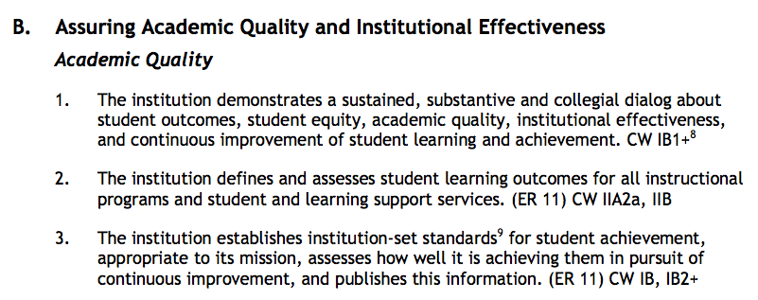
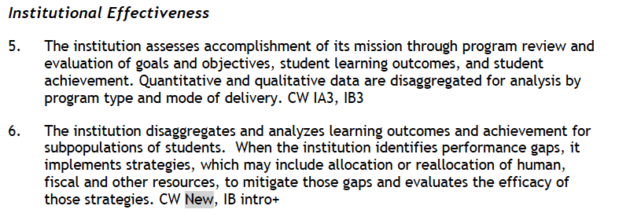
From Standard II:
