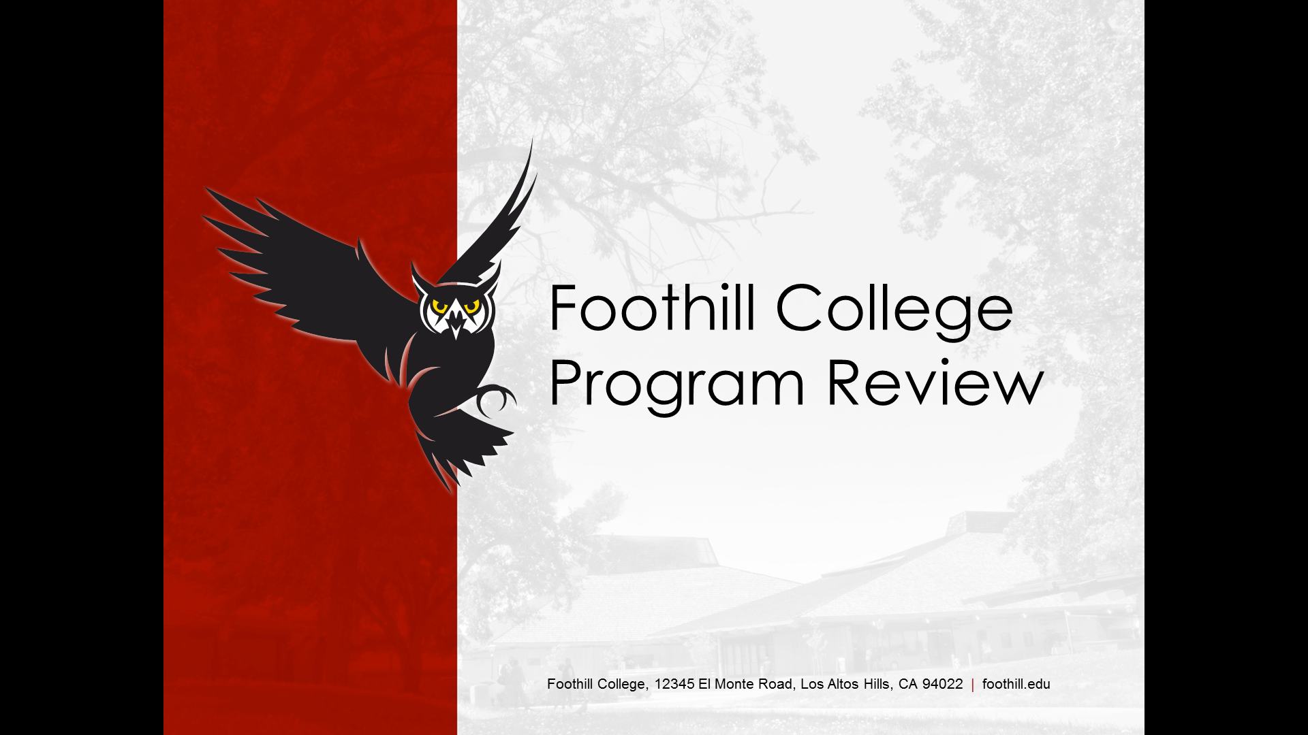

Foothill has amazing faculty, staff and programs. Program Review is about documenting the discussions and plans you have for sustaining and improving student success in your program. It is also about linking your plans to decisions about resource allocations. Thank you for taking the time to review your program and sharing your findings with the college community!

Program Review Committee 2017-18:
Andrew LaManque
Paul Starer‎
Teresa Ong
Carolyn Holcroft
Bruce Mc Leod‎
K Allison Meezan;
Craig Gawlick‎
Jazmine Garcia
Classified Rep (Vacant)
Elaine Kuo (Ex Officio)

Let us know how we can help you!

https://foothill.edu/staff/irs/programplans/index.php
BASIC PROGRAM INFORMATION

Department Name:

Division Name:

Please list all team members who participated in this Program Review:
Name | Department | Position

Number of Full Time Faculty: |  | Number of Part Time Faculty:

Please list all existing Classified positions: Example: Administrative Assistant I

List all programs covered by this review and indicate the program type:
 | Certificate | AA / AS | AD-T | Pathway
 | Certificate | AA / AS | AD-T | Pathway
 | Certificate | AA / AS | AD-T | Pathway
 | Certificate | AA / AS | AD-T | Pathway
 | Certificate | AA / AS | AD-T | Pathway

SECTION 1: PROGRAM ENROLLMENT, PRODUCTIVITY, AND COMPLETION

Data will be posted on Institutional Research’s website for all measures except non-transcriptable completion.

1A. Analysis of Transcriptable Program Completion Data: Please use your data to complete the following table.

Transcriptable Program | Three-year trend in degrees/certificates awarded |  |  | Comments | # of students declaring as their ed goal in 16-17*
e.g. Associate Degree for Transfer | Completion rates have shown a slight increase over the past three years, from 10% to 14% | We are pleased to see this trend and believe it will continue as more students pursue AD-Ts
*according to CCCApply data

1B. Non-Transcriptable Program Data: If your program offers any non-transcriptable programs, please complete the following table. Institutional Research does not track this data; each program is responsible for tracking its own data.

Non-Transcriptable Program | Rationale | Three-year trend | Comments
e.g. Certificate of Proficiency in xx | This credential boosts potential for job advancement in the xx industry. We receive positive feedback from employers (link to advisory committee minutes) | The number of completers has remained steady at around 9 per year | We anticipate that this trend will continue because enrollment in the core classes for this certificate is holding steady

1C. Department-Level Data:
 | 2014-2015 | 2015-2016 | 2016-2017 | Trend
Enrollment
Productivity
Full-Time Load (FTEF)
Part-Time Load (FTEF)

The 2017-18 Annual College Strategic Objectives that will operationalize these 3 EMP goals for academic year 2017-18 are “E2SG” and include:

I. Equity plan – Develop an integrated plan, identify goals for alignment with equity, student success, and basic skills; and focus on efforts to integrate with enrollment strategies (access, retention, and persistence) to close equity gaps while increasing enrollments at the same.
II. Enrollment Growth – Achieve more than 1.5% FTES growth at 500 productivity (+/- 25) with attention to integrating equity efforts related to enrollment, CTE, Sunnyvale Education Center, and education pathway.

1D. Course Enrollment: Discuss plans your program has for ensuring access from all student groups to courses included in the program (both program and GE courses). This might include cross department collaborations, service learning projects, support for student clubs, participation at recruitment events, examination of pre-requisites, review of assessment results, etc.

1E. Productivity: Productivity is a measure of student’s served per full-time equivalent faculty and is a factor in program viability. Please use the program review data sheets to examine your productivity trends. Please check the appropriate box for program review committee readers:

Program Productivity Trend: Increase Steady/No Change Decrease
Program Productivity (Compared to College): Above Goal At Goal Below Goal

The college productivity goal is 500 (+-25). There are many factors that affect productivity (i.e. seat count / facilities / accreditation restrictions, curriculum, etc). Please discuss factors that may be affecting your program’s productivity trends and any plans you have for addressing the trends.

SECTION 2: COURSE COMPLETION & STUDENT ACHIEVEMENT

2A. Course Success Demographics: The College is committed to eliminating differences in achievement and of learning outcomes between student groups. Please examine the Disaggregated Achievement Data Analysis shared with your department and discuss actions you are or plan to take in your department to address and gaps identified in your program. If you are uncertain about actions faculty can take, please take a look at Appendix A.

What resources do you need to implement or sustain your action plans?

2B. Institutional Standard: This represents the lowest course completion (success) rate deemed acceptable by the College’s accrediting body (ACCJC). The institutional standard is 58%.
Please check the appropriate box:
Program Level Course Completion: Above Standard At Standard Below Standard

If your program’s course completion (success) rates are below the institutional standard (see above), please discuss your program objectives aimed at addressing this.

2C. Institutional Effectiveness (IEPI) Goal: This represents an aspirational goal for course completion (success) rates; all programs should strive to reach/surpass this goal. The IEPI goal is 78%.
Please check the appropriate box:
Program Level Course Completion: Above Goal At Goal Below Goal

If your program’s course completion (success) rate is ABOVE the IEPI goal please share your thoughts about why / how this is so.

2C. Faculty Discussion:

Please attach Course and Program-Level Outcomes (Four Column Report from TracDat). Please contact the Office of Instruction if you need help.

2D. Course-Level: Please share examples of how assessment and reflection of course-level Student Learning Outcomes (CL-SLOs) has led to changes in curriculum or teaching.

2E. Program-Level: Please provide examples of how your assessment and dialogue / reflection of program-outcomes (PL-SLOs) have led to certificate/degree program changes and/or improvements?

Please provide examples of what is being done at the program-level to assist students in achieving degree/certificate completion and/or transferring to a four-year institution (e.g. review of progress through the program, “career days” / open houses, mentoring, term by term mapping of suggested courses, etc).

If your department has a Workforce/CTE program, please complete Section 2F.
If your department does not have a Workforce/CTE program, please skip to Section 3.

2F. Workforce/CTE Programs: Refer to the program review website for labor market data.

What is the regional three-year projected occupational growth for your program?

What is being done at the program-level to assist students with job placement and workforce preparedness?

If your program has other program-level outcomes assessments (beyond SLOs and labor market data), discuss how that information has been used to make program changes and/or improvements.

SECTION 3: SUMMARY OF PROGRAM OBJECTIVES & RESOURCE REQUESTS

3A. Past Program Objectives: Please list program objectives (not resource requests) from past program reviews and provide an update by checking the appropriate status box.
 | Year: | Completed | Ongoing | No Longer a Goal
 | Year: | Completed | Ongoing | No Longer a Goal
 | Year: | Completed | Ongoing | No Longer a Goal
 | Year: | Completed | Ongoing | No Longer a Goal
 | Year: | Completed | Ongoing | No Longer a Goal
 | Year: | Completed | Ongoing | No Longer a Goal
 | Year: | Completed | Ongoing | No Longer a Goal

Please comment on any challenges or obstacles with ongoing past objectives.

Please provide rationale behind any objectives that are no longer a priority for the program.

3B. New Program Objectives and Resource Requests: Please list all new program objectives discussed in Sections 1-2, including your objectives to eliminate disproportionate impact (“achievement gaps”) in course success for student subgroups. If additional resources are needed, indicate them in column 4. Refer to the Operations Planning Committee (OPC) website for current guiding principles, rubrics and resource allocation information.
Program Objective | Implementation Timeline | Progress Measures | Additional Resources Needed* | Estimated cost
Example: Offer 2 New Courses to Meet Demand | Winter 2016 Term | Course Enrollment
*specify one-time versus ongoing B-budget augmentation, or facilities/equipment request

3C. EMP Goals. Please refer to the Educational Master Planning (EMP) website for more information. Indicate which EMP goals are supported by your program objectives (Check all that apply).
Create a culture of equity that promotes student success, particularly for underserved students.
Strengthen a sense of community and commitment to the College’s mission; expand participation from all constituencies in shared governance.
Recognize and support a campus culture that values ongoing improvement and stewardship of resources.

3D. Faculty/Staff Position Requests: In the space below, please describe the rationale for any new faculty or staff positions your program is requesting:

3E. Unbudgeted Reassigned Time: Please list and provide rationale for requested reassign time.

3F. Please review the resource requests that were granted over the last three years and provide evidence that the resource allocations supported your objectives and led to student success.

SECTION 4: PROGRAM SUMMARY

4A. Prior Feedback: Address the concerns or recommendations made in prior program review cycles, including any feedback from the Dean/VP, Program Review Committee (PRC), etc.
Concern/Recommendation | Comments

4B. Summary: What else would you like to highlight about your program (e.g. innovative initiatives, collaborations, community service/outreach projects, etc.)?

SECTION 6: FEEDBACK AND FOLLOW-UP

This section is for the Dean/Supervising Administrator to provide feedback.

6A. Strengths and successes of the program as evidenced by the data and analysis:

6B. Areas of concern, if any:

6C. Recommendations for improvement:

6D. Recommended Next Steps:
Proceed as Planned on Program Review Schedule
Further Review / Out-of-Cycle In-Depth Review

This section is for the Vice President/President to provide feedback.

6E. Strengths and successes of the program as evidenced by the data and analysis:

6F. Areas of concern, if any:

6G. Recommendations for improvement:

6H. Recommended Next Steps:
Proceed as Planned on Program Review Schedule
Further Review / Out-of-Cycle In-Depth Review

Upon completion of Section 6, the Program Review document should be returned to department faculty/staff for review, then submitted to the Office of Instruction and Institutional Research for public posting. Please refer to the Program Review timeline.

