|  |
| --- |
| **PROGRAM REVIEW IN TRACDAT – CONCEPT DEMONSTRATION** |

**GOAL: INSERT/TRACK RESPONSES FROM THE ANNUAL PROGRAM REVIEW FORM**

For each assessment unit (administrative, instructional, and student services), responses can be added to the *General* sub-heading.

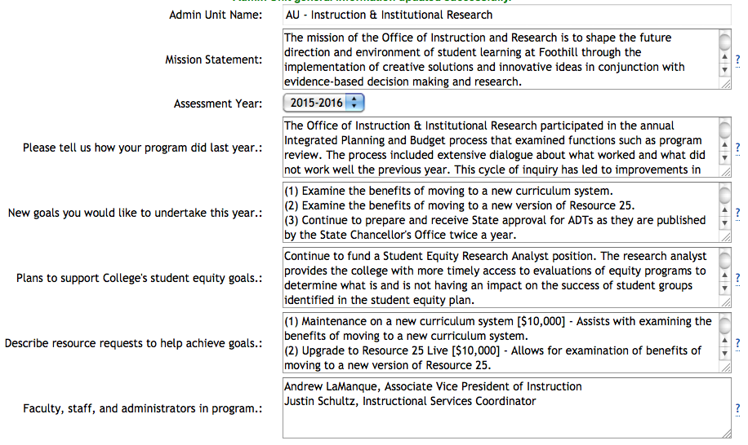

The full question(s) cannot be posted on the main screen. TracDat limits each prompt title to 50 characters.

The full question requires use of the “?” button on the right side of each text box. If the user clicks the icon, a pop-up will appear.

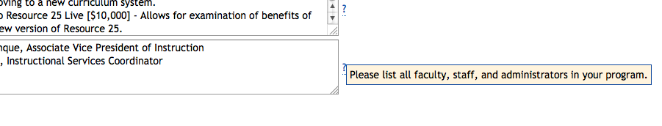

An **AD HOC** report can be used to track completion as well as compile a master list of all programs with their associated responses. Running the report requires selecting *Data View: Assessment Unit – General* and all relevant units participating in annual program review.

**PDF VIEW**

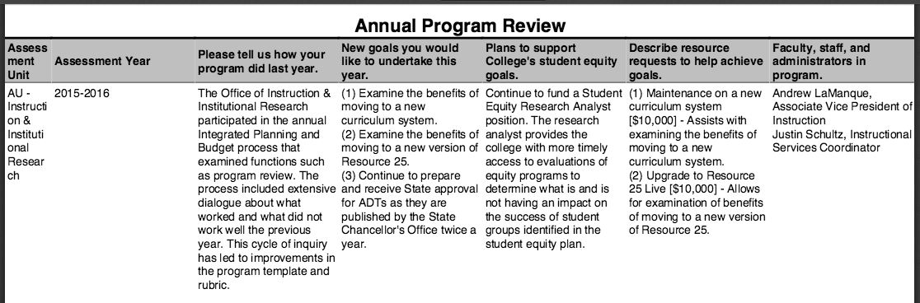

**EXCEL VIEW**

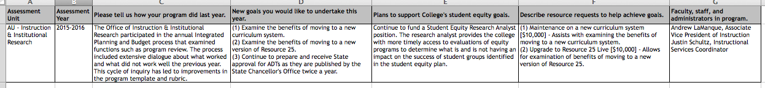

**BENEFITS:**

1. Less physical documents to track; all responses housed in one database.
2. Administrators can easily track completion of prompts within their divisions (or college-wide).
3. Responses can be gathered and posted online without needing multiple PDF files.

**LIMITATIONS:**

1. The responses to the annual program review cannot automatically be tracked over time.
2. The option to enter the assessment year exists, this will only be helpful when running reports and compiling the data. All responses would need to be archived (excel or PDF) prior to the next program review cycle. When the new information is entered, the old data is overwritten.

*Temporary Solution: Users could add new responses underneath older ones and indicate the assessment year. Unfortunately, this would yield very messy reports and require extensive manipulation on the back-end.*

A long-term solution to this limitation is currently in development, but Nuventive estimates another 12 months (minimum) – upgrading to TracDat V5.0 will not solve this issue.